**Initial Design Concept**

Amarthya Sivakumar Annu (Project Manager)

Austin Peterson

Yingjian Wang

**Name: Sports Tracking Web Application**

APIs:

-NBA

-NFL

-MLB

-other leagues…

-tickets/ticket prices (seat geek) (hiroku)

**Initial Design Concept:**

• Application Name: You should choose a compelling name for your project that clearly conveys the goal of the project and what it does.

-Sport Tracker

• Project Description: Give a description of the application.

-Track sports games throughout the week and display the results of each one

• The goal of the project: what do you want this application to be able to do?

-This application should track sports events for different sports leagues, such as the NBA, NFL, MLB, NHL(?), etc…, with each league having its own page. Each game should display the resulting score and, if possible, any information on important plays or MVPs for each game. The user should also be able to filter/search by different team names and keep track of scheduled games in the near future.

Stretch goals:

* Display team data, such as team roster and player stats
* Include more detailed data on each game

Fallback goals:

* Include twitter feed for each game
* Include less prominent leagues/sports, like tennis or golf

• **Planned Report Authors**.

The Initial Design report - Amarthya Siakumar Annu

A User Study Proposal and User Stories report. - Austin Peterson

The User Study Results and Design Change report - Yingjian Wang

The Team Retrospective report. - All the members.

• Interface Sketch. You should prepare a sketch/mock-up of your user interface. Hand-drawn sketches are highly discouraged unless they are part of the product. If your application will have multiple levels, you may need to have sketches of several screens.

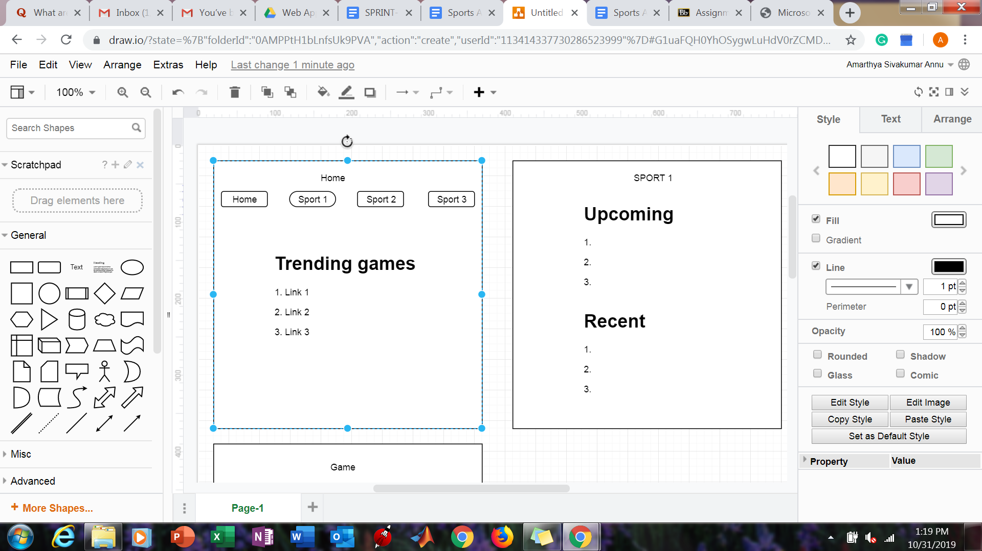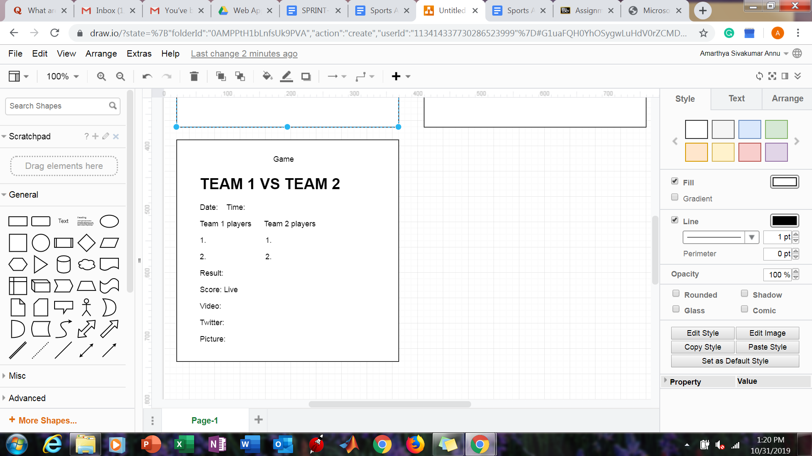

Tasks:

---------------------------Initial Design---------------------------------

1. Brainstorm application ideas
2. Make a final design decision
3. Discuss requirements
4. Create product backlog
5. Create a burndown chart
6. Create a design document
7. Sketch initial design
8. Delegate jobs (writing reports, PM)
9. Design Sprint 1 backlog
10. Determine code methodology/language
11. Delegate backlog tasks
12. Make official design drawings

--------------------------------Sprint 1----------------------------------

1. Determine website creation method (template, pure html/CSS, website element designer)
2. Create the website files
3. Create site navbar
4. Create upcoming games section
5. Create recent games section
6. Add league/sport pages
7. Add league/sport logos
8. Implement interactive aspects (scrolling, dynamic game block creation)
9. Search for the APIs
10. Choose the appropriate APIs
11. Format API return data
12. Link API data with website elements (game blocks)
13. Filter hot games for “home” page
14. Filter games by sport for sports pages
15. Get images for each game block

--------------------------------Sprint 2----------------------------------

1. Design game block link page
2. Link recap video (through API?)
3. Format game time data
4. Format game date data
5. Format teams involved data
6. Include previous game data if multiple games played in a series (fallback)
7. Format final score data
8. Format score throughout the game data (by quarter, inning, etc)
9. Add design elements - pictures
10. Add general team data
11. Include next game between the teams if possible (fallback)
12. Add key moments/highlights from the game
13. Add MVP data if possible (kind of the same as above)
14. Team color code
15. Start user testing
16. Collect user data/feedback
17. Complete user study report
18. Make appropriate changes based on user feedback

--------------------------------Sprint 3----------------------------------

1. Start filter by team process (search for a team, get data for their games)
2. Create a modified sport page for individual teams
3. Find team info API
4. Link team info with team page
5. Build team player grid(?)
6. Finish team pages
7. Add twitter feeds to game pages
8. Clean up site/make final design changes
9. Test links/pages

Product burndown chart:

